Download Dataset - <https://data.cityofnewyork.us/browse?q=parking+tickets>

Note: Consider only the year 2017 for analysis and not the Fiscal year.

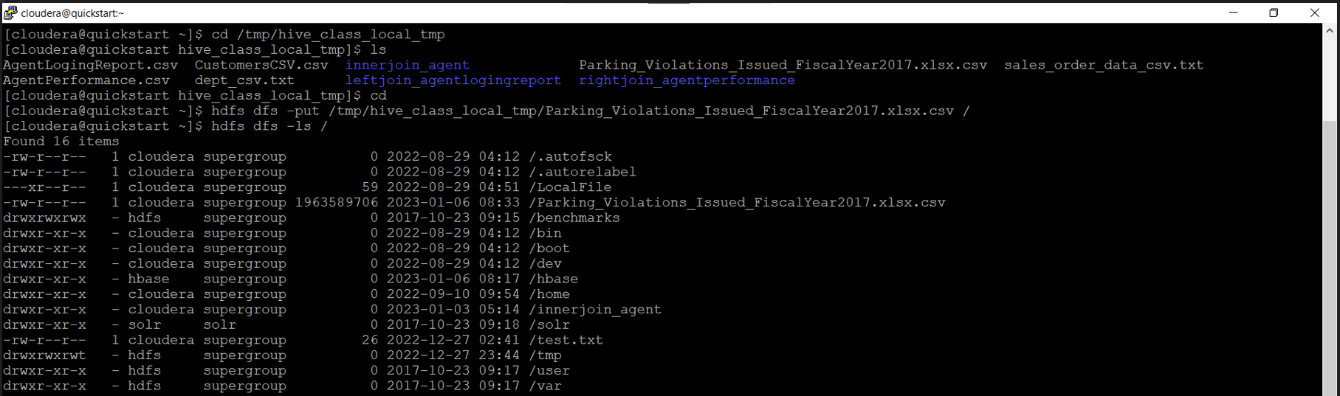

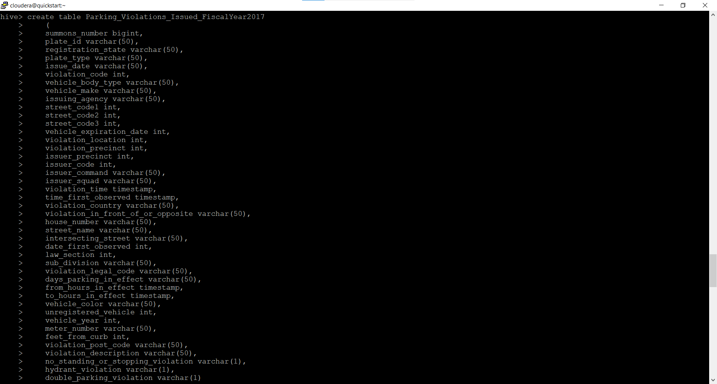

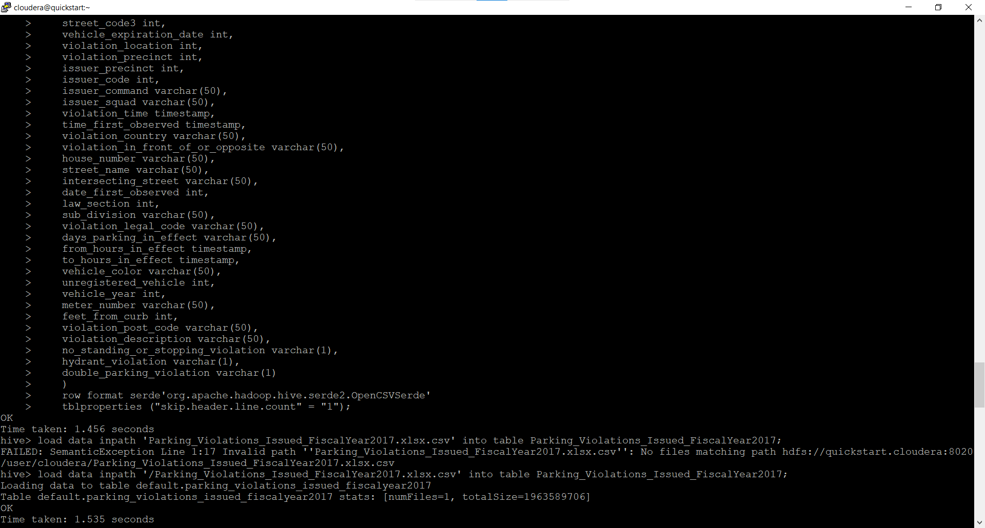

Z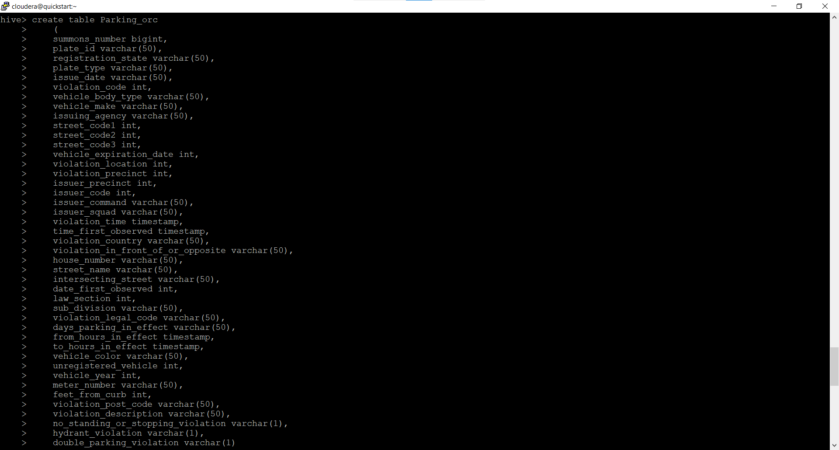

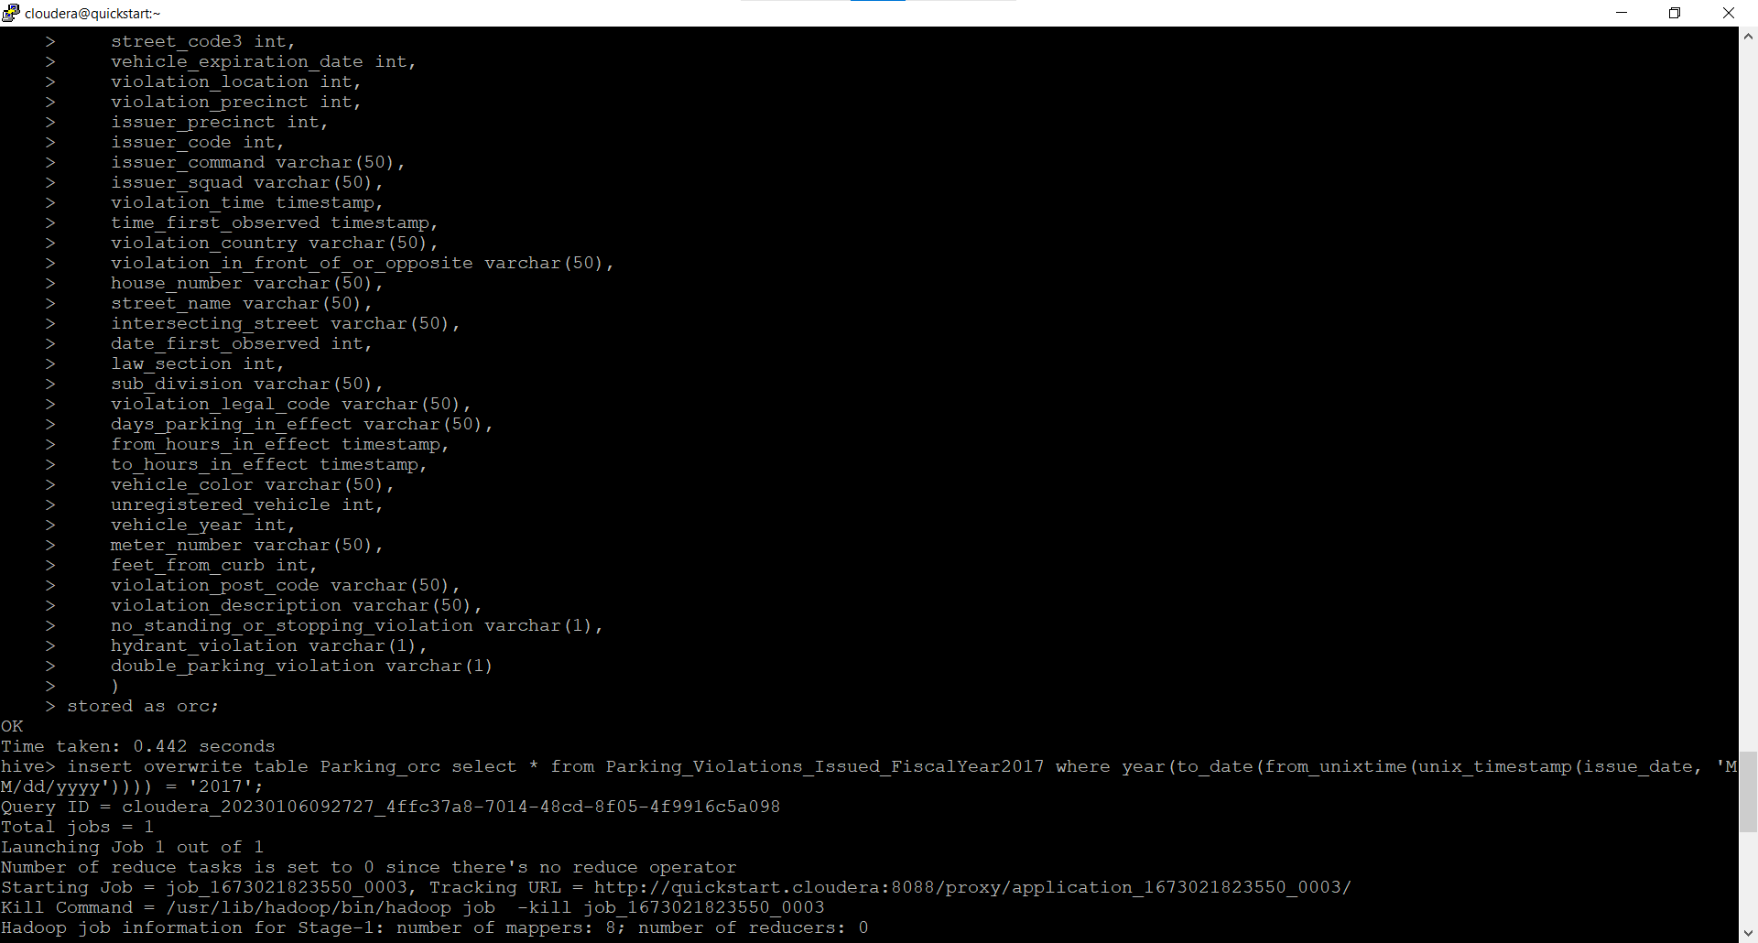

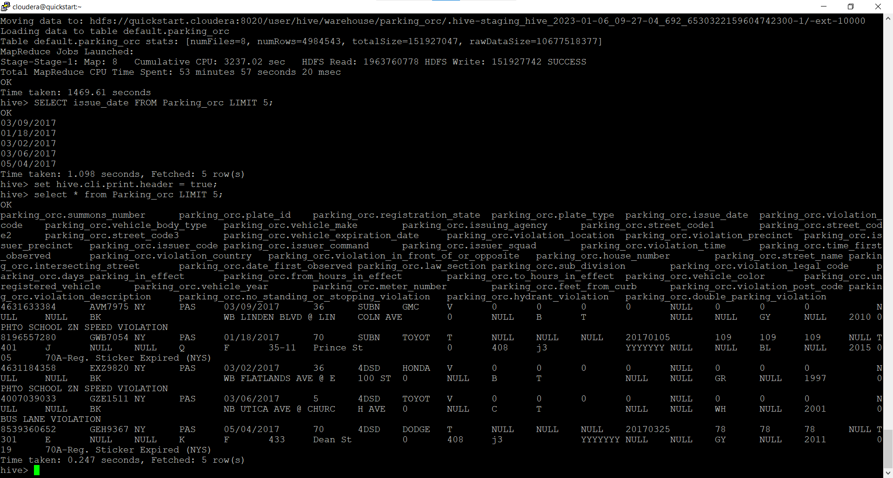

1. Find the total number of tickets for the year

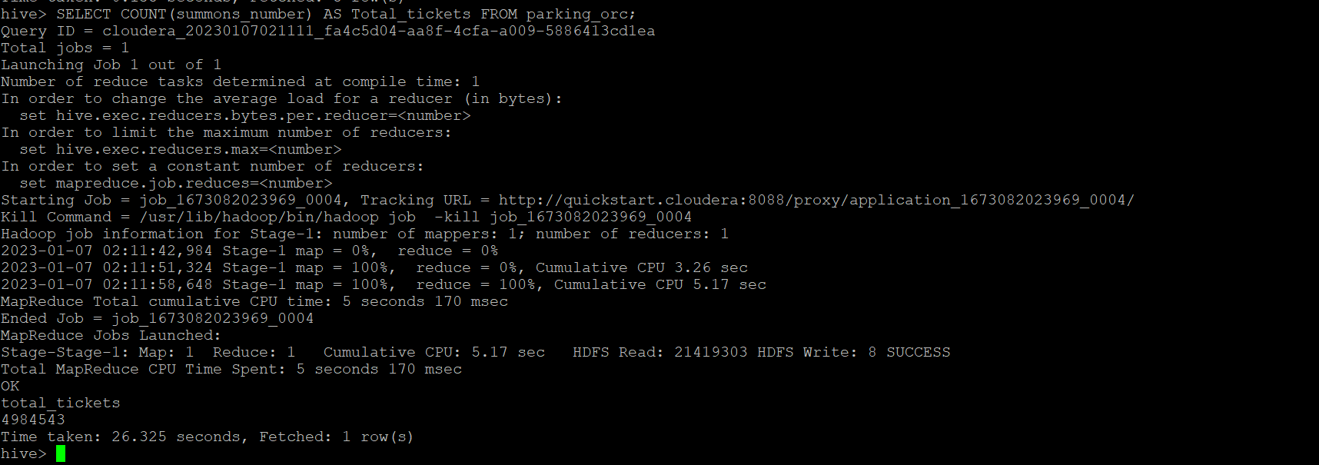

1. Find out how many unique states the cars which got parking tickets came from

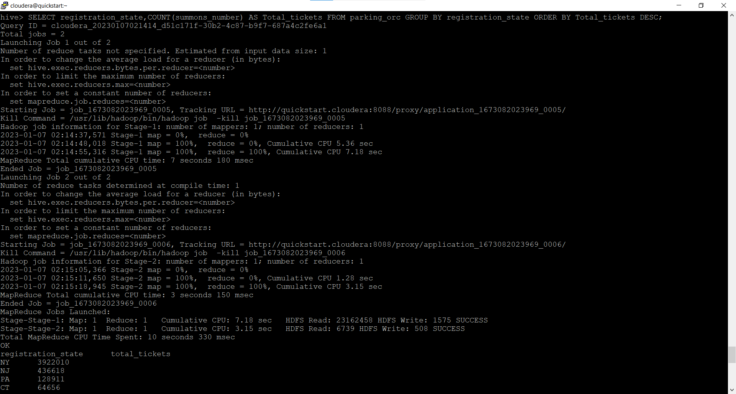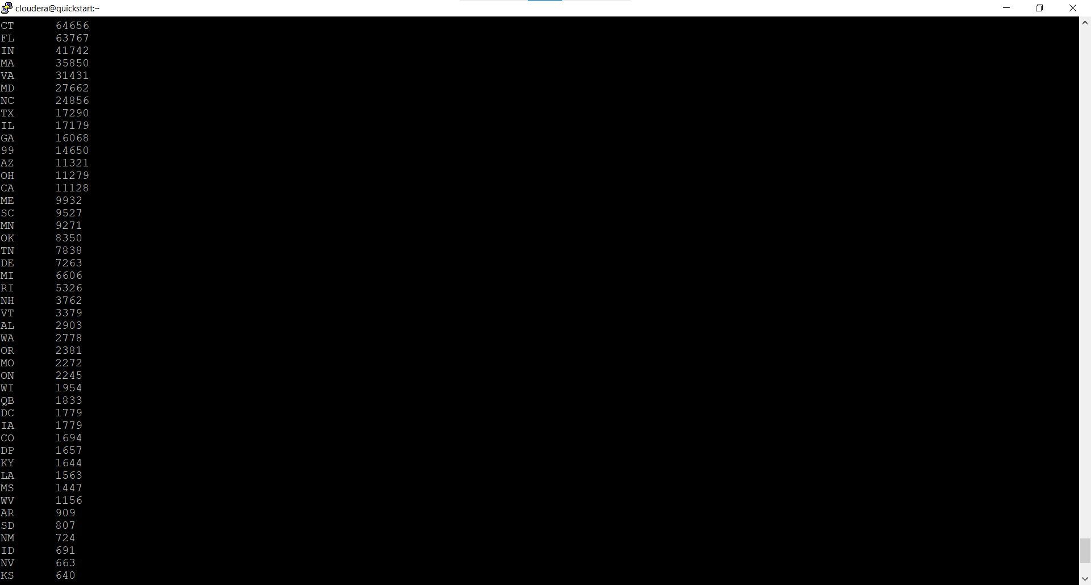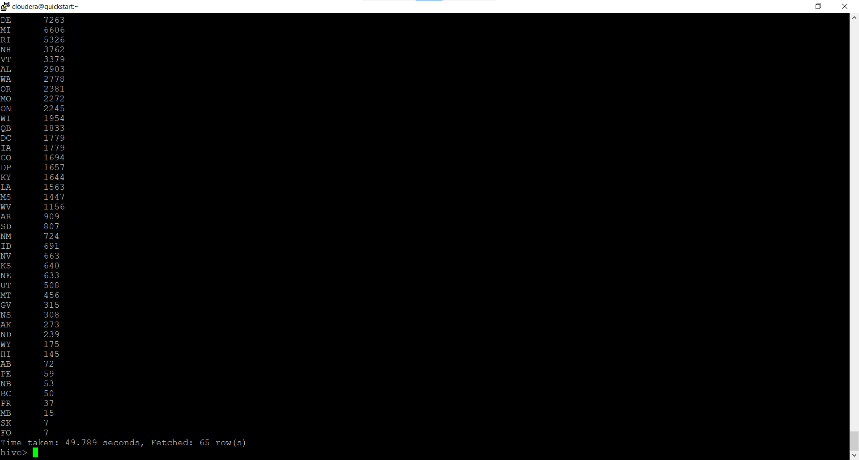

1. Some parking tickets don’t have addresses on them, which is cause for concern. Find out how many such tickets there are(i.e. tickets where either "Street Code 1" or "Street Code 2" or "Street Code 3" is empty )

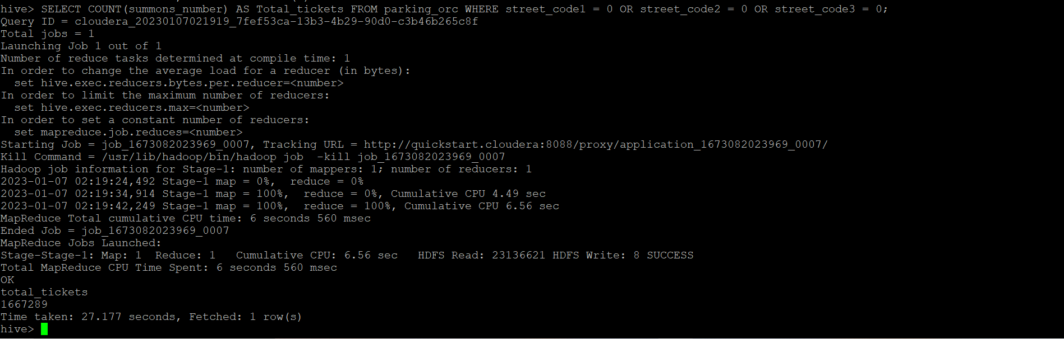

**Part-II: Aggregation tasks**

1. How often does each violation code occur? (frequency of violation codes - find the top 5)

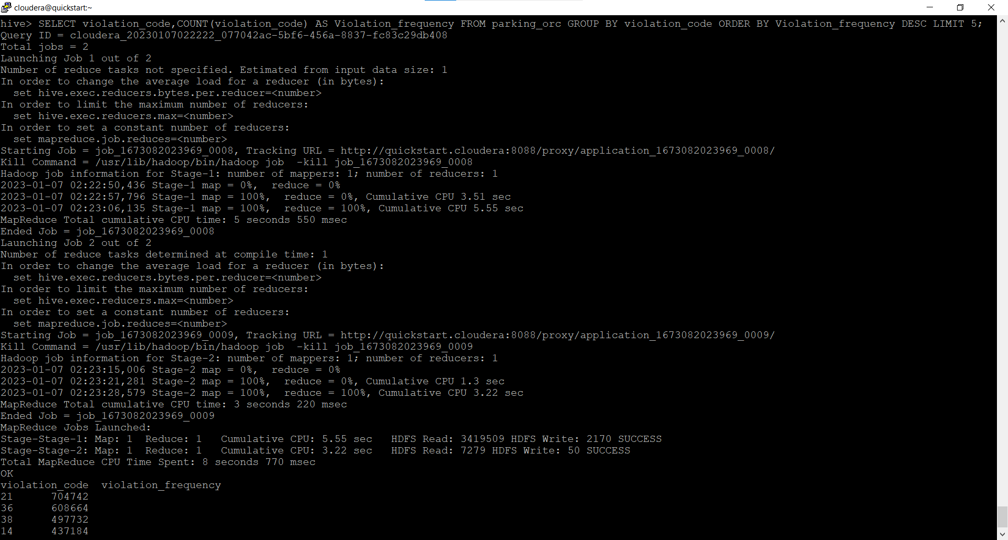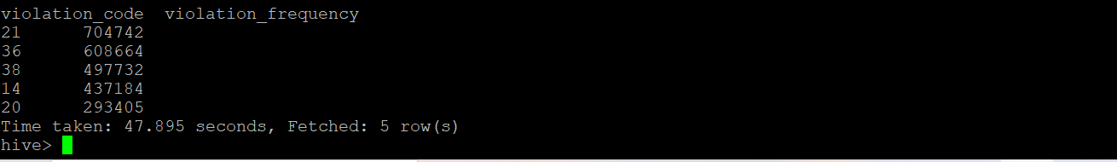

1. How often does each vehicle body type get a parking ticket? How about the vehicle make? (find the top 5 for both)

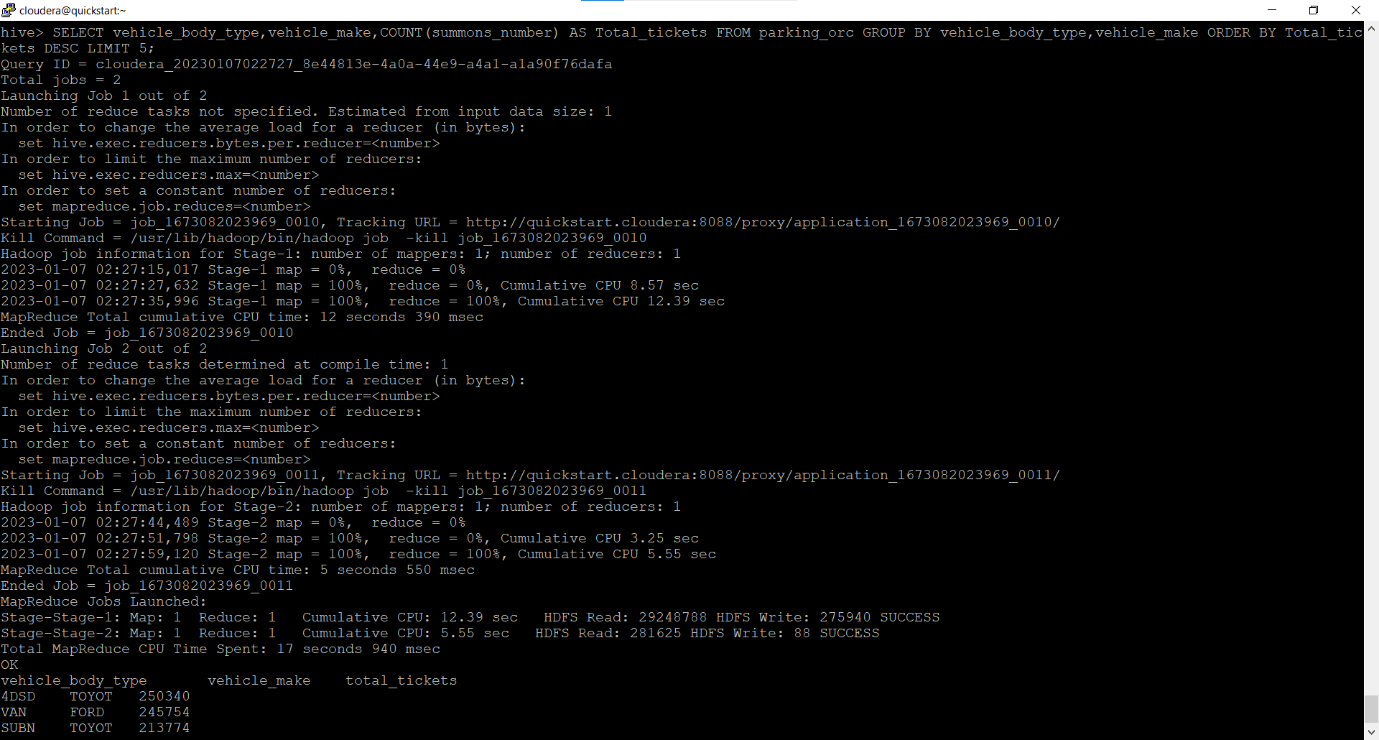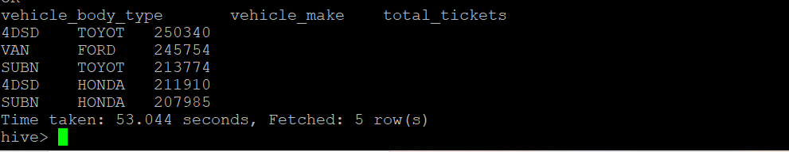

1. A precinct is a police station that has a certain zone of the city under its command. Find the (5 highest) frequencies of:
2. Violating Precincts (this is the precinct of the zone where the violation occurred)

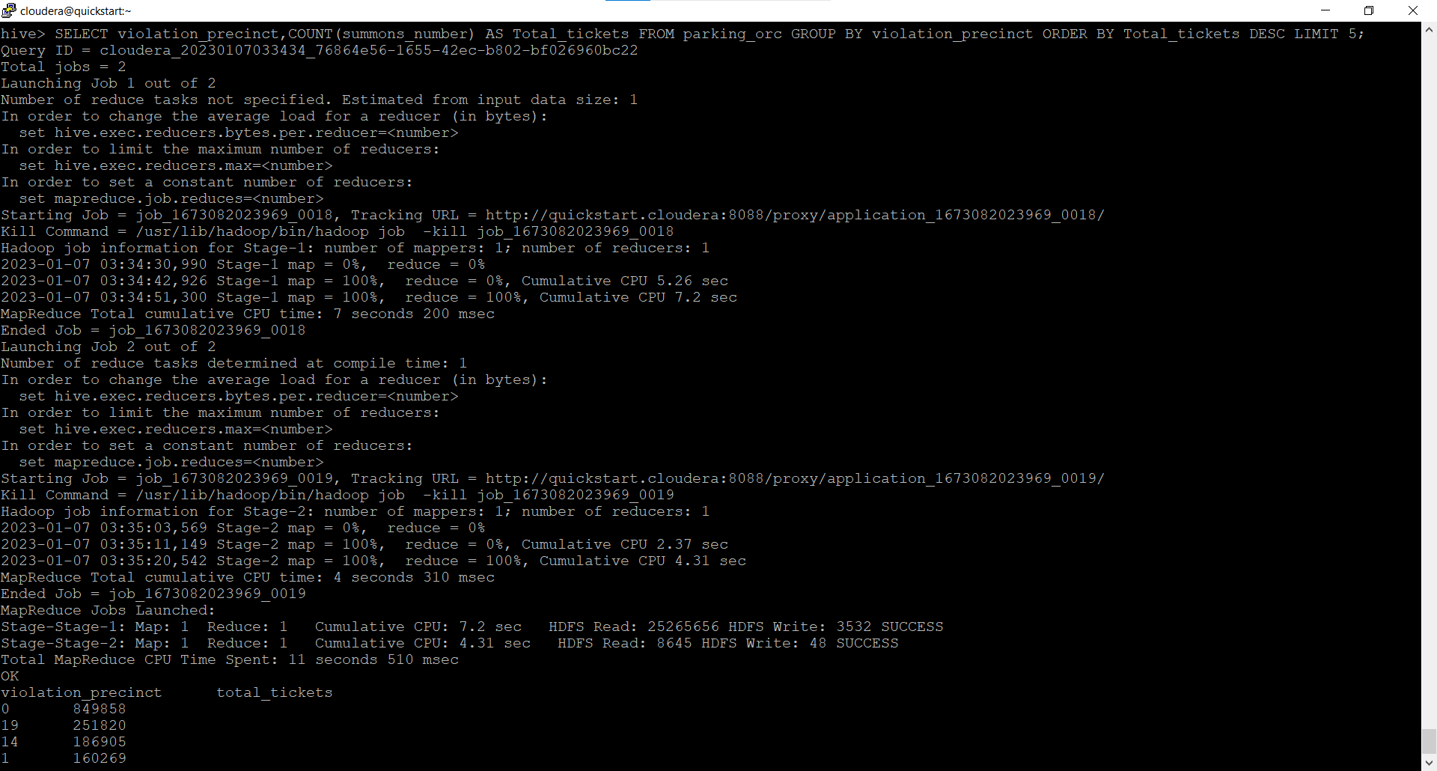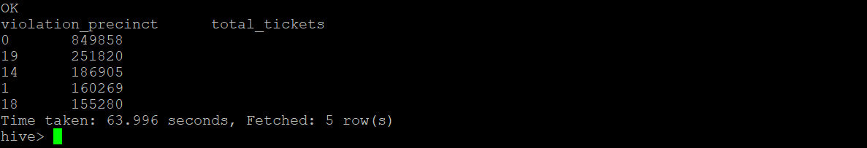

1. Issuer Precincts (this is the precinct that issued the ticket)

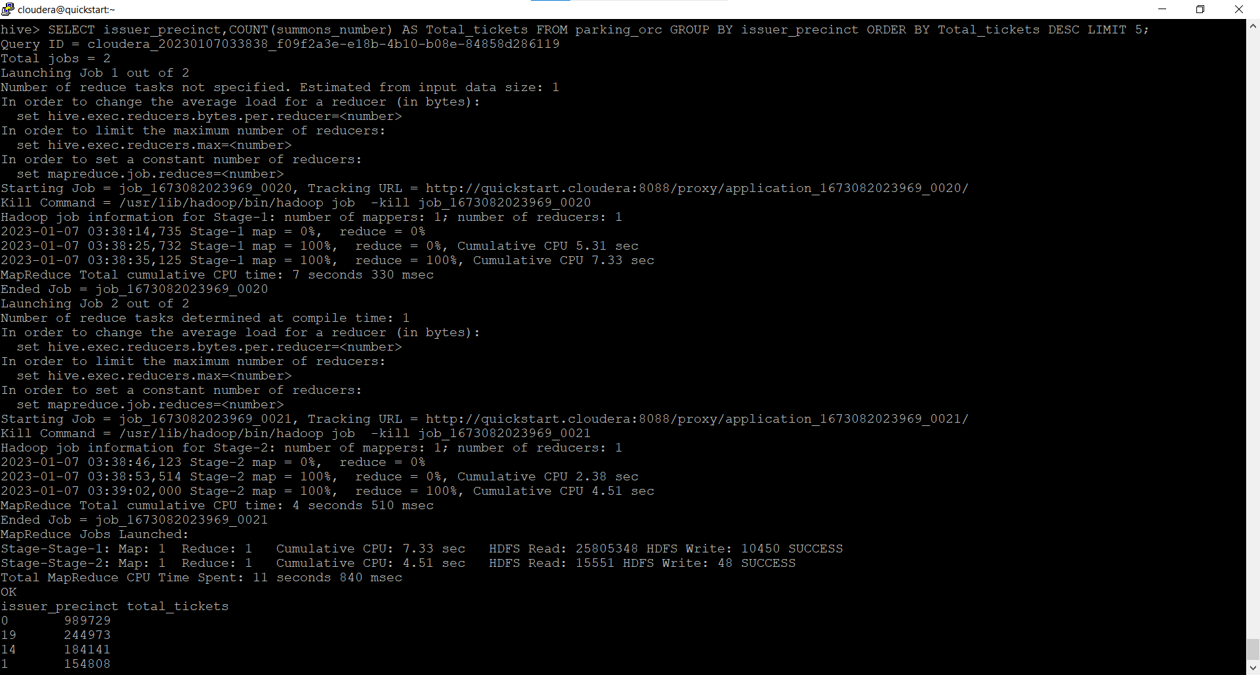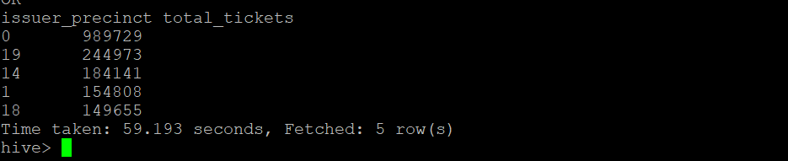

1. Find the violation code frequency across 3 precincts which have issued the most number of tickets - do these precinct zones have an exceptionally high frequency of certain violation codes?

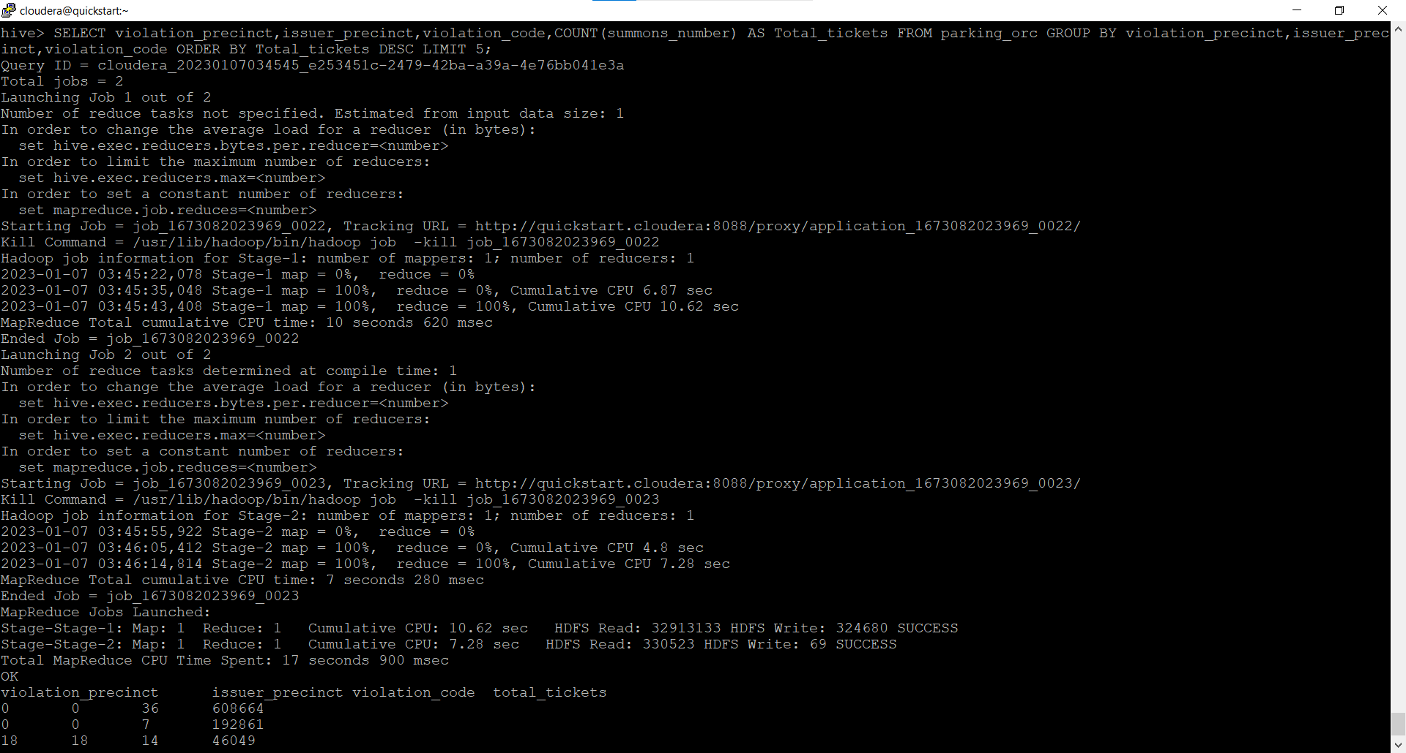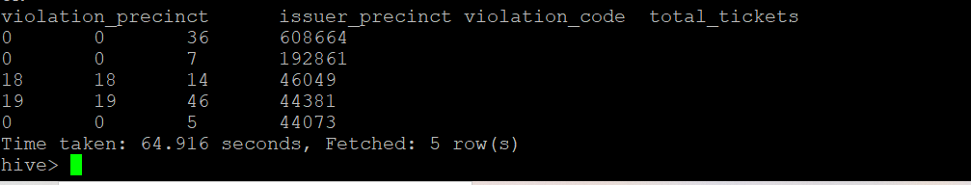

8.) Let’s try and find some seasonality in this data

a.) First, divide the year into some number of seasons, and find frequencies of tickets for each season. (Hint: A quick Google search reveals the following seasons in NYC: Spring(March, April, March); Summer(June, July, August); Fall(September, October, November); Winter(December, January, February))

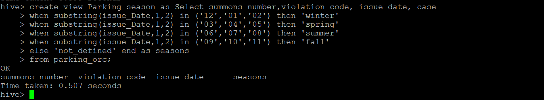

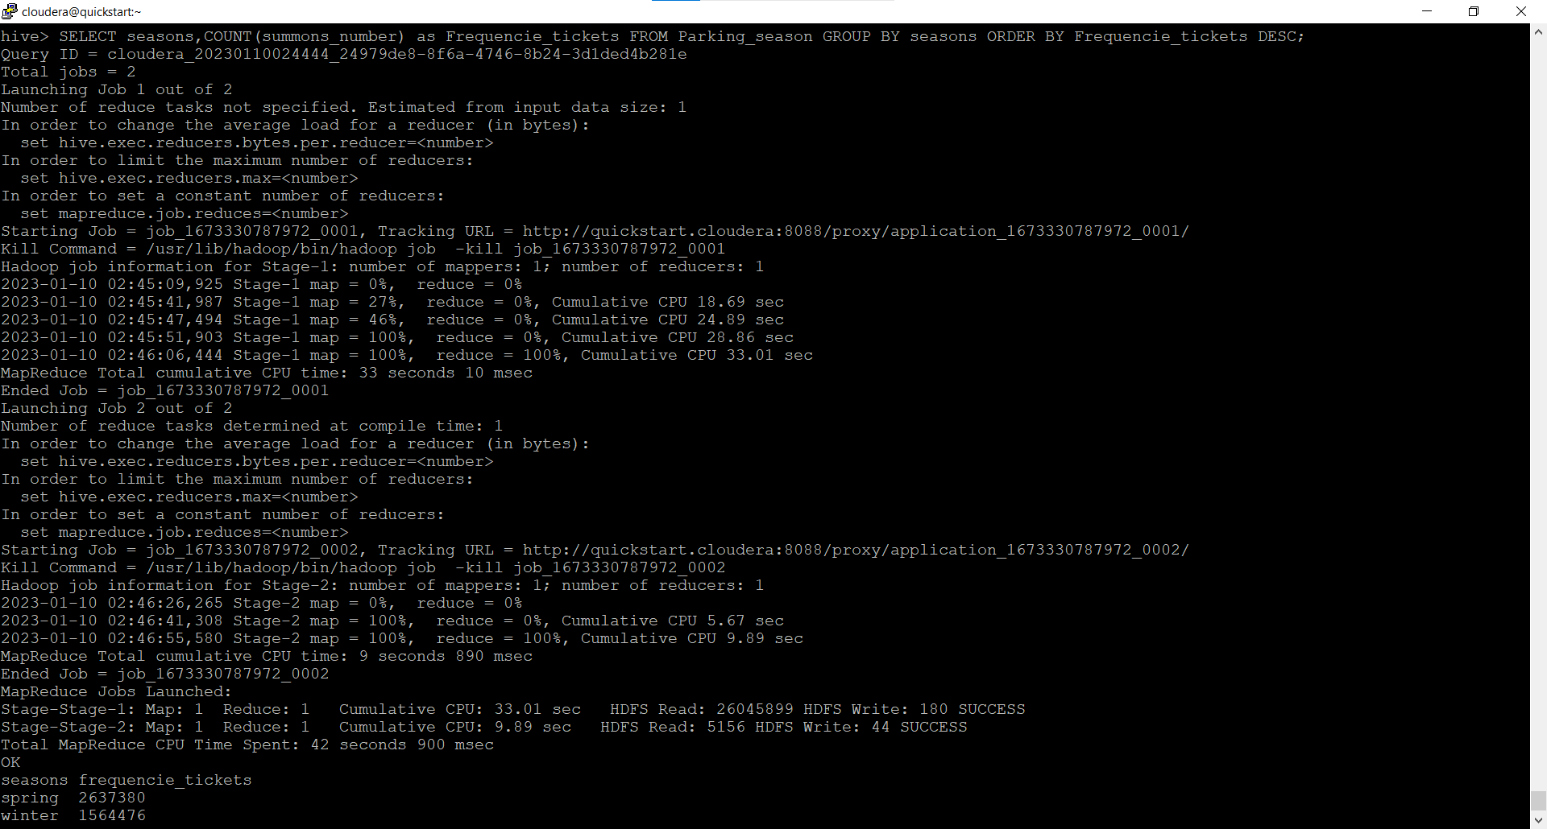

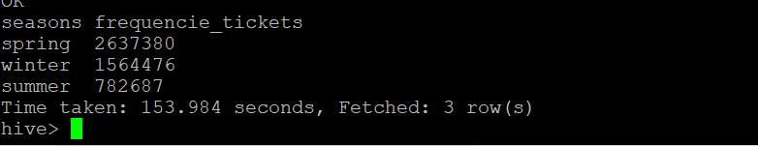

b.)Then, find the 3 most common violations for each of these seasons

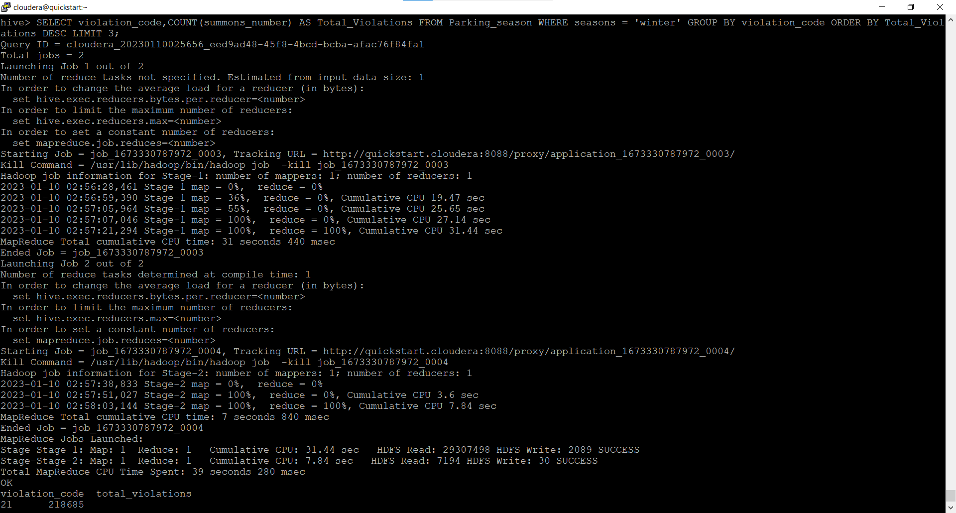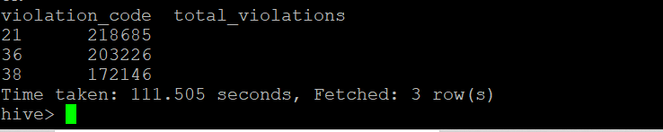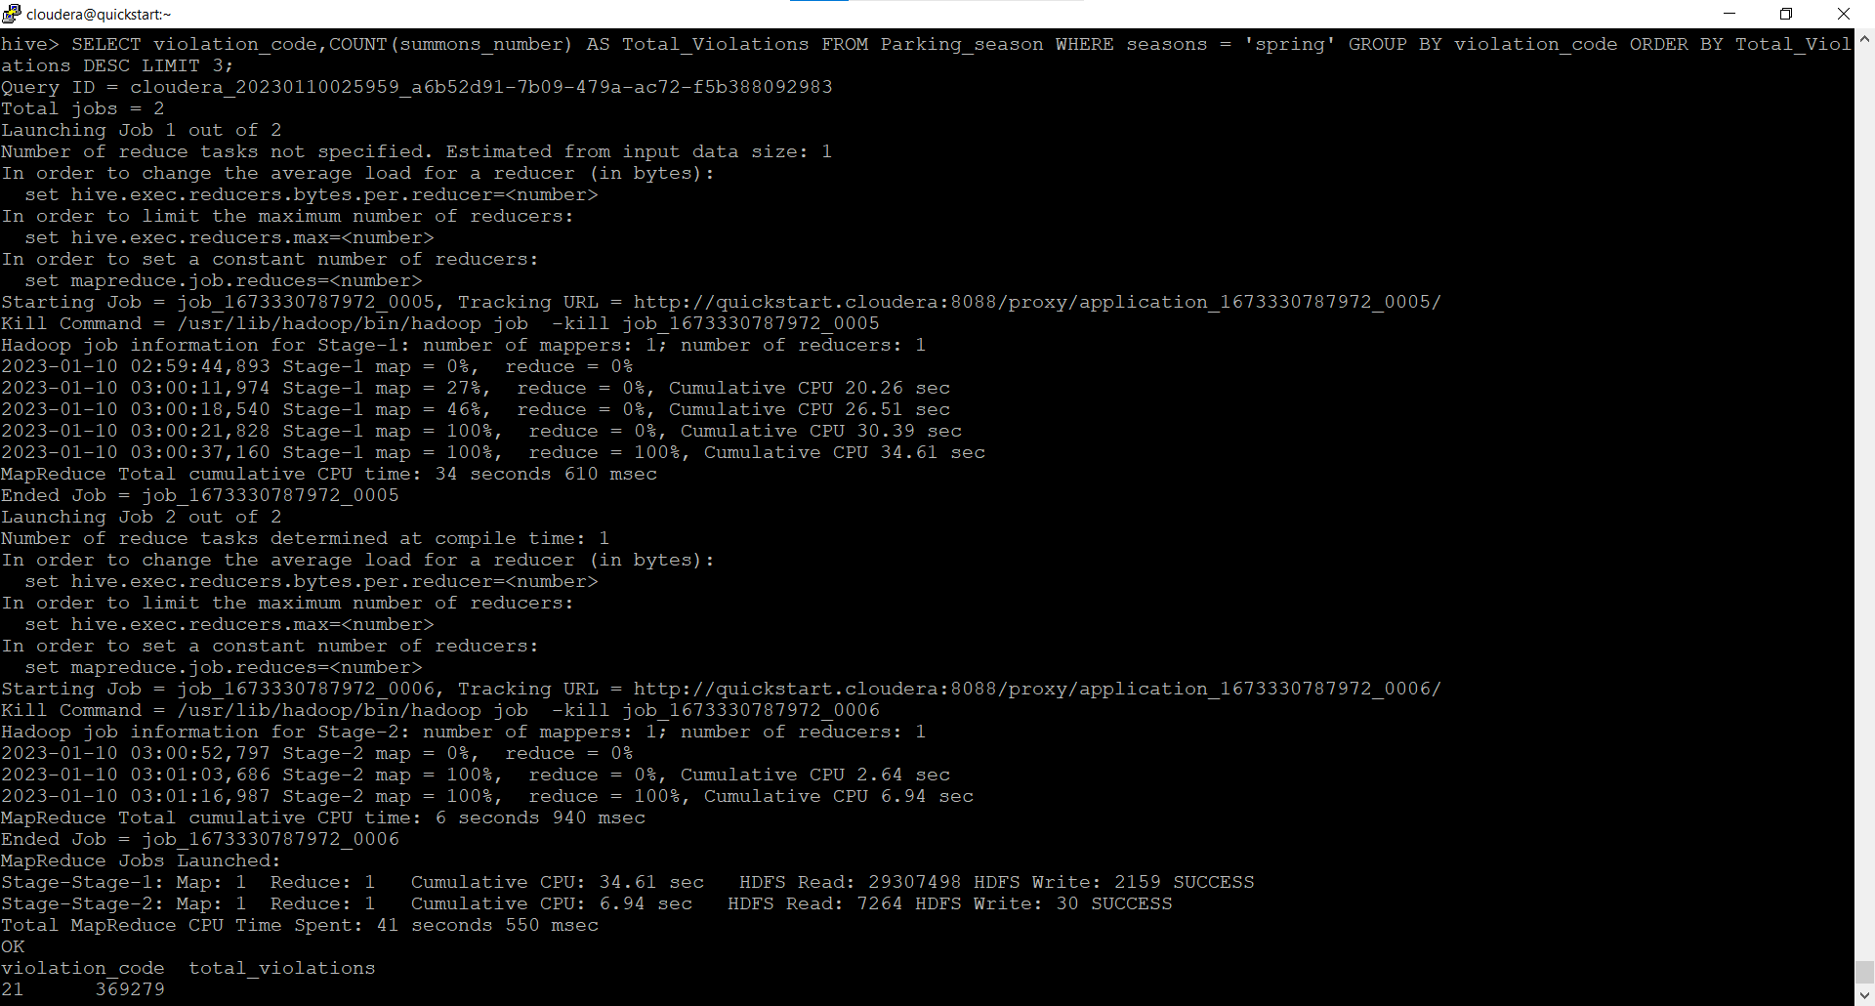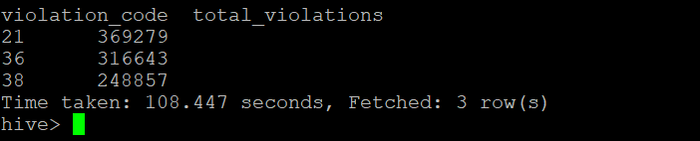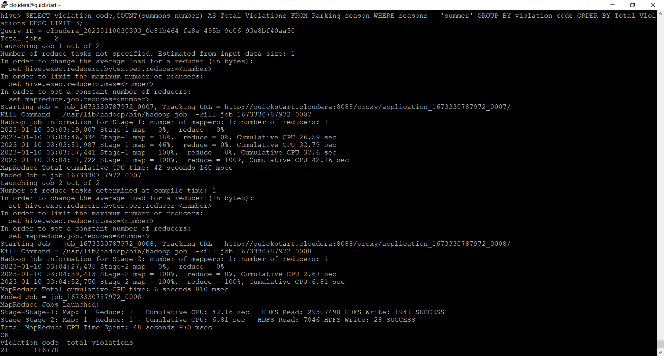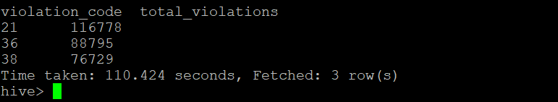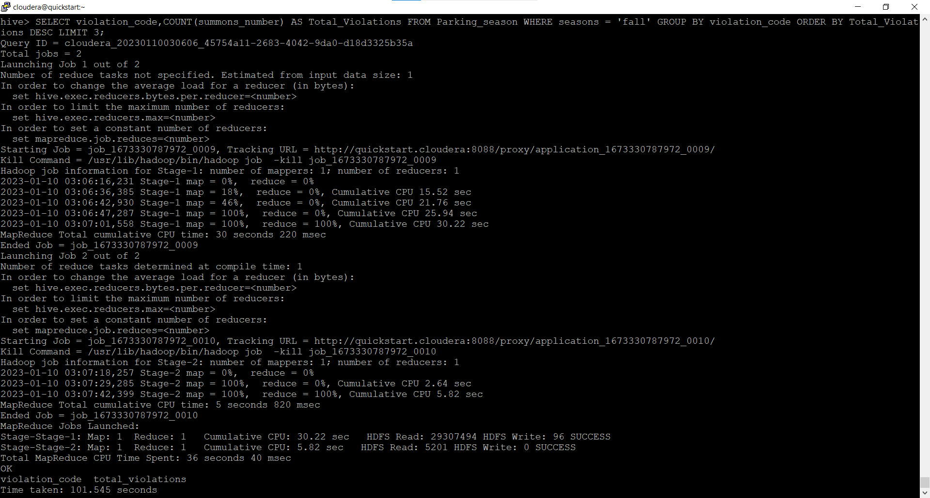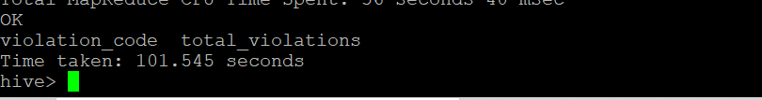

PARTITIONING



  
  
  
    

  
  
  
  
  
  
  
  